Online Pet Store System
SR | USER Requirements | GPT Results | VeriGen Results
 | The Customer clicks the log-in button on the Home Page. | 1 The system shall provide the customer with the ability to click the log-in button on the Home Page. | 1. The system shall provide customer with the ability to click the login button on the home page.
 | The system displays the log-in page. | 2 The system shall be able to display the log-in page when the log-in button is clicked. | 2. The system shall be able to display the login page.
 | The customer enters his login Id with password. | 3 The system shall provide the customer with the ability to enter a login ID on the log-in page.  4 The system shall provide the customer with the ability to enter a password on the log-in page. | 3. The system shall provide customer with the ability to enter his login i d with password.
 | The customer clicks on the confirm button. | 5 The system shall provide the customer with the ability to click the confirm button after entering login credentials. | 4. The system shall provide customer with the ability to click on the confirm button.
 | The system checks that all of the required information was entered. | 6 The system shall be able to check that both login ID and password have been entered. | 5. The system shall be able to check that all of the required information entered.
 | If the entered information is wrong then system asks customer to reenter the details. | 7 If the login ID or password is missing, then the system shall be able to display an error message requesting the customer to enter all required information.  9 If the entered login ID or password is incorrect, then the system shall be able to prompt the customer to re-enter the login details.  - If the entered login ID and password are correct, then the system shall be able to confirm successful login to the customer.  11 The system shall be able to display a login error message if the entered email address and password are incorrect. | 6. If the entered information is wrong then the system shall be able to ask customer to reenter details.
 | The system validates the entered information against the tables stored in the database. | 8 The system shall be able to validate the entered login ID and password against the stored user credentials in the database. | 7. The system shall be able to validate the entered information against the tables stored in the database.
 | Customer browser has to be linked to supplier catalog Web site before the starting of the process. | 12 The system shall require that the customer’s browser is linked to the supplier catalog website before starting the process. | 8. The system shall provide browser with the ability to have to linked to supplier catalog web site before the starting of the process.
 | The Customer requests to browse catalog. | 13 The system shall provide the customer with the ability to request to browse the catalog. | 9. The system shall provide customer with the ability to browseThe system shall be able to display login page , login usecase carried out.
 | System displays login page, Log-in usecase is carried out. | 14 The system shall be able to display the login page when the customer requests to browse the catalog.  15 The system shall be able to carry out the login use case when the customer requests to browse the catalog. | Missing
 | If the customer is not registered then the system asks customer to get registered. | 16 If the customer is not registered, then the system shall be able to prompt the customer to register. | 10. If the customer is not registered then the system shall be able to register asks customer to.
 | Customer enters email address with a password. | 17 The system shall provide the customer with the ability to enter an email address during registration.  18 The system shall provide the customer with the ability to enter a password during registration. | 11. The system shall provide customer with the ability to enter email address with a password.
 | System confirms correct login. | 19 The system shall be able to confirm correct login after successful authentication. | 12. The system shall be able to confirm correct login.
 | If the entered email address with password is incorrect then system shows login error message. | Missing | 13. If the entered email address with password is incorrect then the system shall be able to show login error message.
 | The system displays catalog information to customer. | 20 The system shall be able to display catalog information to the customer after successful login. | 14. The system shall be able to displays information customer.
 | The catalog consists of the categories of pets- dogs, cats , birds. | 21 The system shall be able to display pet categories in the catalog, including dogs, cats, and birds. | 15. The system shall be able to consists catalog categories pets dogs , cats , birds.
 | The system asks user to select the pet category. | 22 The system shall prompt the customer to select a pet category from the catalog.  23 The system shall provide the customer with the ability to select a pet category from the catalog. | 16. The system shall be able to ask user to select the pet category.
 | The customer selects the pet category, browses items. | 24 The system shall provide the customer with the ability to browse items within the selected pet category. | 17. The system shall provide customer with the ability to select the pet category , browses items.
 | The customer selects the items for Pet category from the catalog. | 25 The system shall provide the customer with the ability to select items from the chosen pet category. | 18. The system shall provide customer with the ability to select the items for pet category from the catalog.
 | If Customer does not select any Pet category from the displayed catalog then the system asks customer to browse related items for pets from the catalog. | 26 If the customer does not select any pet category, then the system shall be able to prompt the customer to browse related items for pets from the catalog. | 19. If customer does not select any pet category from the displayed catalog then the system shall be able to ask customer to browse related items for pets from catalog.
 | The system displays a list of items with price. | 27 The system shall be able to display a list of items with their respective prices for the selected pet category. | 20. The system shall be able to display a list of items with price.
 | Customer has to be logged in before placing an order, Log-in usecase is carried out. | 28 The system shall require the customer to be logged in before placing an order.  29 The system shall be able to carry out the login use case before allowing the customer to place an order. | 21. The system shall provide customer with the ability to have to logged in before placing an order , login usecase carried out.
 | From the list of items for Pets from catalog, customer selects the items for his Pet. | 30 The system shall provide the customer with the ability to select items for their pet from the catalog. | 22. The system shall provide customer with the ability to select the items for his pet.
 | System presents detailed information about the items. | 31 The system shall be able to present detailed information about each selected item to the customer. | 23. The system shall be able to present detailed information about the items from the selected pet category (dogs, cats, or birds).
 | Customer adds the selected item to a shopping cart. | 32 The system shall provide the customer with the ability to add selected items to a shopping cart. | 24. The system shall provide customer with the ability to add the selected item to a shopping cart by browsing the list of items with price and viewing detailed item information.
 | Shopping cart contents is presented to the customer. | 33 The system shall be able to present the contents of the shopping cart to the customer. | 25. The system shall be able to presented shopping cart contents customer.
 | Customer selects proceed to checkout option. | 34 The system shall provide the customer with the ability to select the "proceed to checkout" option from the shopping cart. | 26. The system shall provide customer with the ability to proceedThe system shall provide customer with the ability to enter shipping address.
 | Customer enters shipping address. | 35 The system shall provide the customer with the ability to enter a shipping address during checkout. | Missing
 | System presents shipping options. | 36 The system shall be able to present available shipping options to the customer during checkout. | 27. The system shall be able to present shipping options by the customer enters the shipping address.
 | The customer selects shipping option. | 37 The system shall provide the customer with the ability to select a shipping option. | 28. The system shall provide customer with the ability to select shipping option by entering the shipping address during the checkout process.
 | System asks which credit/debit card will be used. | 38 The system shall prompt the customer to select which credit or debit card will be used for payment. | 29. The system shall be able to ask which credit debit card used.
 | Customer selects to use the credit card which is stored in the system. | 39 The system shall provide the customer with the ability to select a stored credit card for payment. | 30. The system shall provide customer with the ability to use stored in.
 | If customer wants to use another card for payment then he enters details of that card. | 40 If the customer chooses to use another card, then the system shall provide the customer with the ability to enter details of a new credit or debit card. | 31. If customer wants to use another card for payment then the system shall be able to enter he details of that card.
 | System asks for final confirmation to place an order. | 41 The system shall prompt the customer for final confirmation before placing the order. | Missing
 | Customer places an order. | 42 The system shall provide the customer with the ability to place an order after confirmation. | 33. The system shall provide customer with the ability to place an order by selecting items from the shopping cart, entering shipping address, selecting a shipping option.
 | System returns confirmation number. | 43 The system shall be able to return a unique confirmation number to the customer after successful order placement. | 34. The system shall be able to return confirmation number.
 | A delivery order must exist. | 44 The system shall ensure that a delivery order exists for each placed order. | 35. The system shall be able to exist delivery order.
 | The supplier needs to log in, Log-in usecase is carried out. | 45 The system shall require the supplier to log in before accessing delivery orders.  46 The system shall be able to carry out the login use case for the supplier. | 36. The system shall provide supplier with the ability to need to log in , login usecase carried out.
 | The System displays the delivery order made by customer to supplier. | 47 The system shall be able to display the delivery order made by the customer to the supplier. | 37. The system shall be able to display the delivery order made by customer to supplier.
 | The supplier checks the order. | 48 The system shall provide the supplier with the ability to check the details of the delivery order. | 38. The system shall provide supplier with the ability to check the order after logging into the system and viewing the list of customer orders displayed by the system.
 | The supplier determines that items are available in inventory to satisfy delivery order. | 49 The system shall provide the supplier with the ability to determine if items are available in inventory to satisfy the delivery order. | 39. The system shall provide items with the ability to determine that available in inventory to satisfy delivery order.
 | If item is out of stock then the supplier rejects the delivery of that order by asking system to select another supplier. | 50 If an item is out of stock, then the system shall provide the supplier with the ability to reject the delivery of that order.  51 If an item is out of stock, then the system shall be able to allow the supplier to select another supplier for fulfilling the order. | Missing
 | The System reserves the selected items for a customer. | 52 The system shall be able to reserve the selected items for the customer after order placement. | 41. The system shall be able to reserve the selected items for a customer after the supplier verifies item availability.
 | The System displays the inventory information to Supplier. | 53 The system shall be able to display inventory information to the supplier. | 42. The system shall be able to display the inventory information to supplier.
 | The System confirms that the items are reserved to be delivered. | 54 The system shall be able to confirm to the supplier that the items are reserved for delivery. | 43. The system shall be able to confirm that the items reserved to delivered after checking inventory availability and supplier approval.
 | To check the status of the order, the customer must have placed an order. | 55 The system shall require that the customer has placed an order before allowing order status checks. | 44. The system shall provide customer with the ability to place an order.
 | Customer enters login id with password, Log-in use case is carried out. | 56 The system shall provide the customer with the ability to enter login ID and password to check order status.  57 The system shall be able to carry out the login use case when the customer checks order status. | 45. The system shall provide customer with the ability to enter login i d with password , login use case carried out.
 | The system validates the customer. | 58 The system shall be able to validate the customer’s credentials during order status check. | 46. The system shall be able to validate the customer by checking the entered login ID and password.
 | System presents main page. | 59 The system shall be able to present the main page to the customer after successful login. | 47. The system shall be able to present main page for assisting user after successful login.
 | The system displays a list of available options. | 60 The system shall be able to display a list of available options to the customer on the main page. | 48. The system shall be able to display a list of available options.
 | The customer selects check order status from the list. | 61 The system shall provide the customer with the ability to select "check order status" from the list of options. | 49. The system shall provide customer with the ability to checkThe system shall be able to show all the available orders.
 | The system shows all the available orders. | 62 The system shall be able to show all available orders to the customer after selecting "check order status." | Missing
 | If there is no active order, then the system displays a message that no active order is available. | 63 If there is no active order, then the system shall be able to display a message indicating that no active order is available. | 50. If there is no active order, then the system shall be able to display a message that no active order available after the customer selects check order status.
 | The customer selects the order he wants to check for status. | 64 The system shall provide the customer with the ability to select an order to check its status. | 51. The system shall provide customer with the ability to select the order items wants to check for status.
 | The system displays the status of that order. | 65 The system shall be able to display the status of the selected order to the customer. | 52. The system shall be able to display the status of that order after the customer selects an order from the list of available orders.
 | The customer clicks on OK button. | 66 The system shall provide the customer with the ability to click the OK button after viewing order status. | 53. The system shall provide customer with the ability to click on ok button.
 | The system shows Thank you message. | 67 The system shall be able to display a "Thank you" message after the customer clicks the OK button. | 54. The system shall be able to show thank you message upon successfully viewing the status of the selected order.
 |  | 68 The system shall validate all user input fields for required data before processing actions.
 |  | 69 The system shall handle and log all authentication errors for both customers and suppliers.
 |  | 70 The system shall provide real-time feedback to users on the success or failure of each action performed.

Class Diagram (GPT)

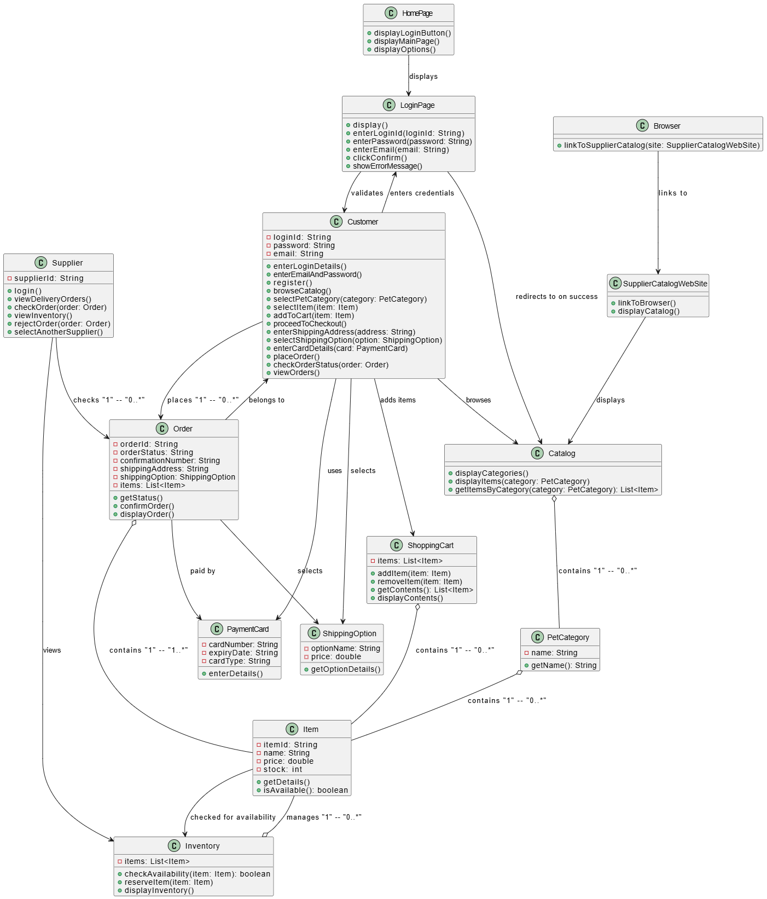

Class Diagram (VeriGen)

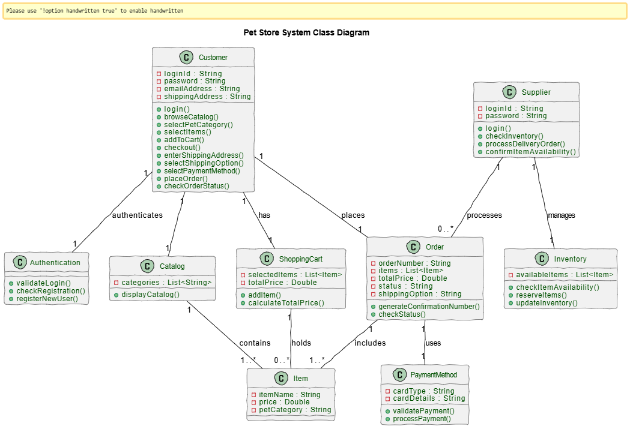

Sequence Diagram (VeriGen)
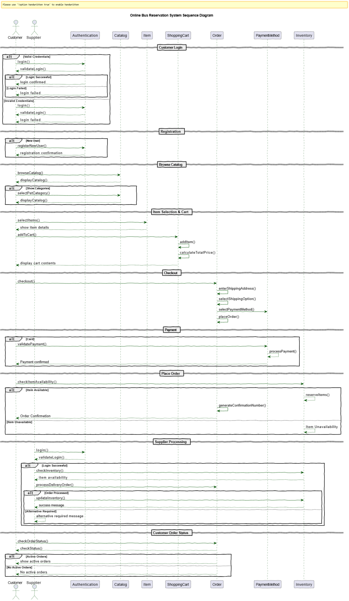

Sequence Diagram (GPT)

